# Exercise: Intro to DOM

Problems for exercises and homework for the ["JavaScript Fundamentals" course @ SoftUni](https://softuni.bg/trainings/2247/js-fundamentals-january-2019)   
 Submit your solutions in the SoftUni judge system at <https://judge.softuni.bg/Contests/1426>

## Cards

In this problem, you should **create a JS functonality** which **checks all cards**, and shows which

one **is greater** and **keeps history of all hands**.

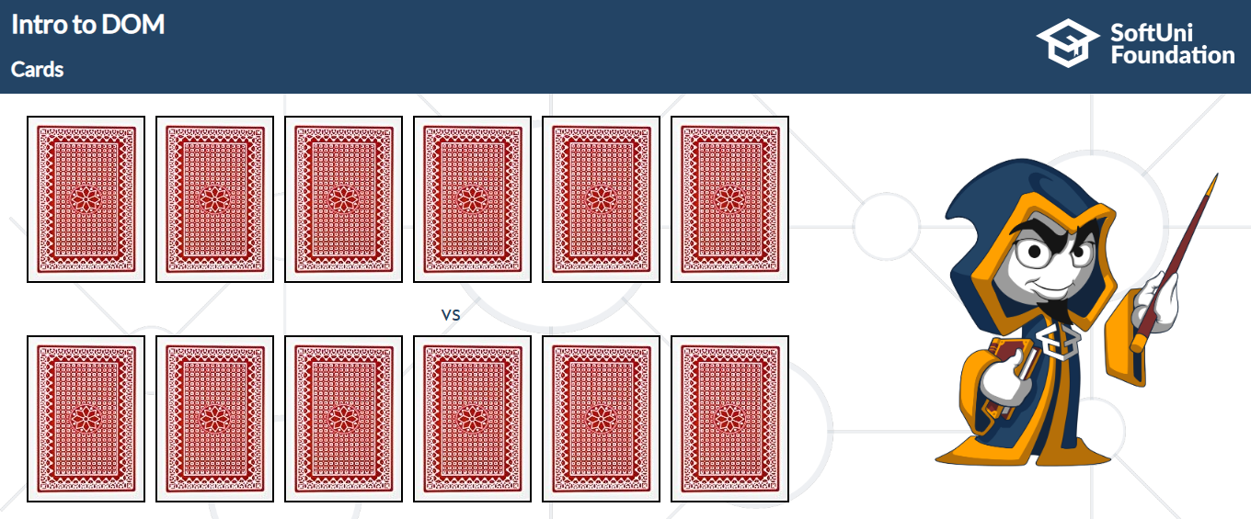

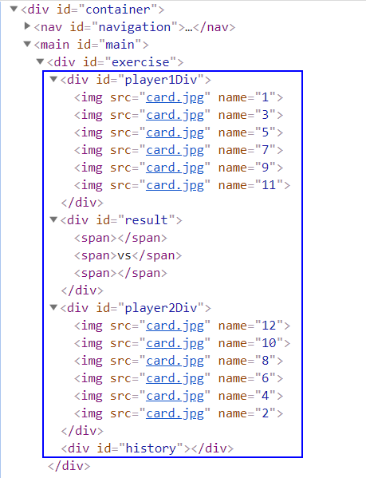

First of all, you need to **add** **click events** to **all cards**. After that, when some of the cards are clicked, the current background card must be changed with "**whiteCard.jpg**" picture (Which is given to us with the skeleton) and **append** the **card name** to the one of the **span elements into the div with id result.**

**If a card from the top side is clicked**, you should **append** **the card name** to **the left span** (first empty span), otherwise you should **append** **the** **card name** to **the right span** (second/last span).

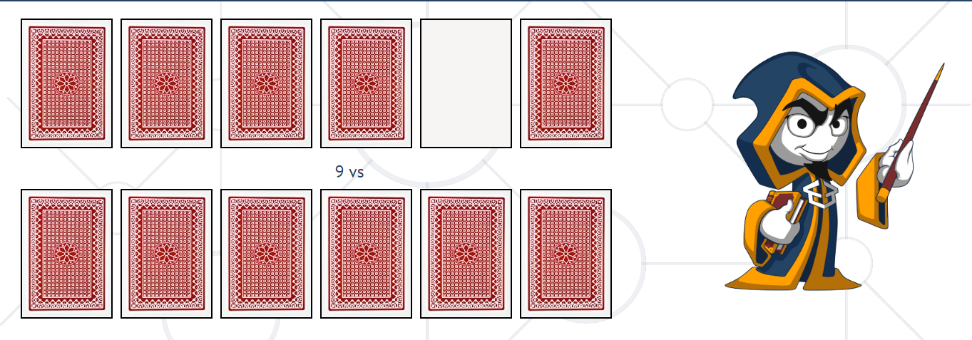

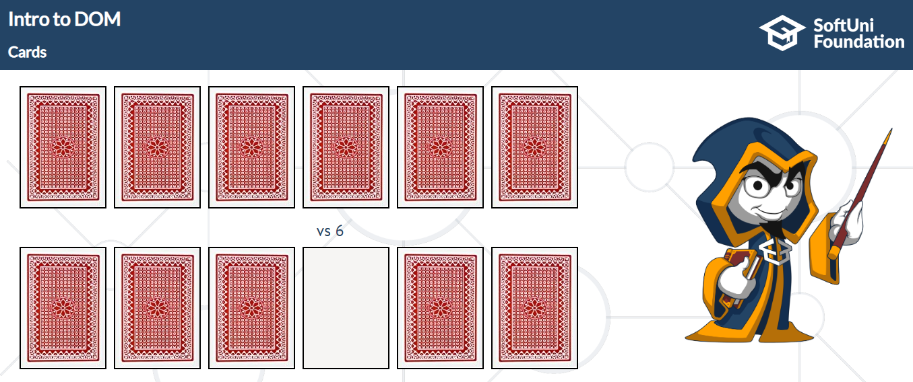

When **one card** from **both sides** **is selected,** you should **check** which card name is **greater**. The greater card must be bordered with "**2px solid green**" and lower card with "**2px solid darkred"**.

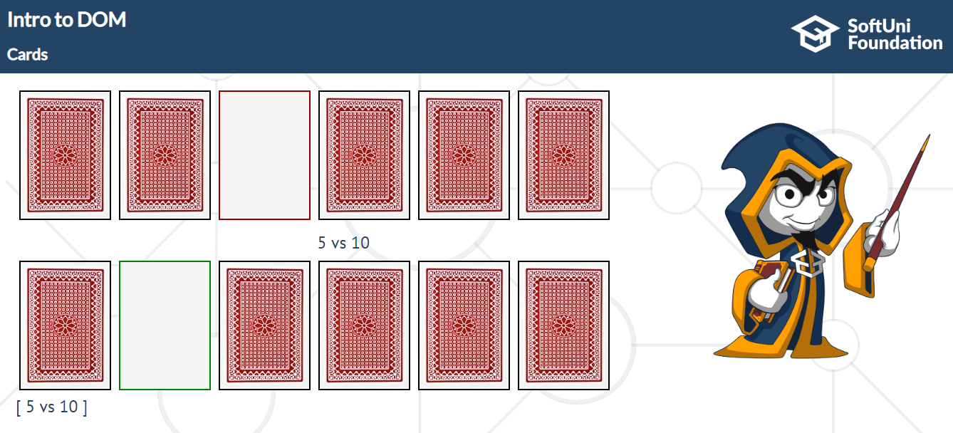

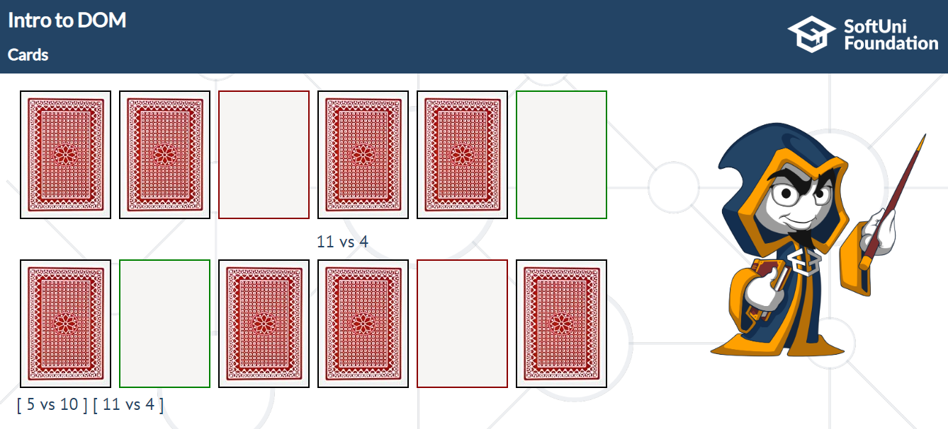

After that you should use setTimeOut **function** to **clear** the **span elements** which **hold current cards names. (**Use **2000 ms** to solve it**).** Also, **after every hand** you should push the current cards names to the history div in format:

**[**{top side card name} **vs** {bottom side card name}**]**

If we take for example, the examples so far, after 2 or more seconds the expected result should be… (**look the next example below**).

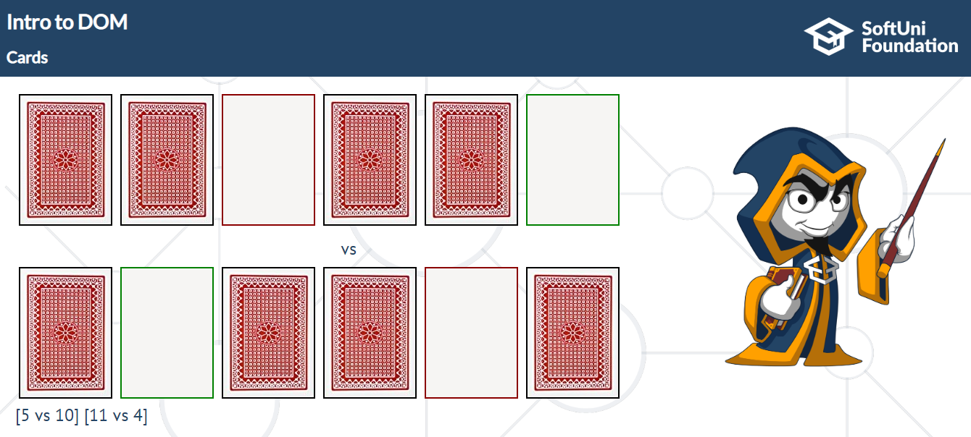

## Chat room with Pesho

In this problem, you should **create a JS functonality** which **creates a chat room where we chat**

**with our good friend Pesho.**

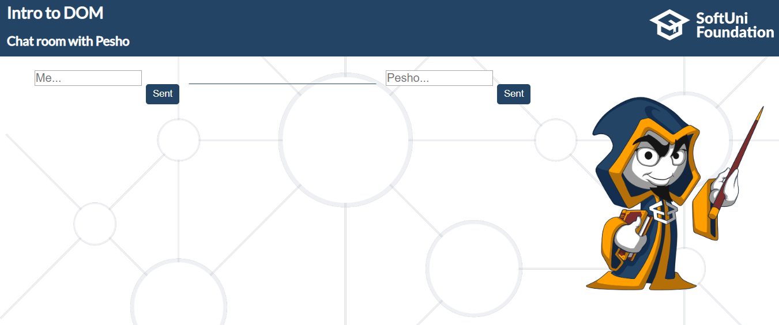

First of all, **don’t forget** to **add event listeners** to **both of the buttons**!

Any sent message, regardless of the sender, is saved into a **div element**. This div contains **two elements** (**span** and **paragraph**).

**The span element** should contain only the sender name (Me or Pesho).

**The p element** should contain the current message.

The final step is to append the **current div** to the div which has an **id** **chatChronology.**

**Keep in mind that** if the sender is "Me", the **text-align** inside the current div should be **left**, otherwise when Pesho sends some message the **text-align** needs to be **right**.

Аfter each click on the buttons, **the current message should be cleared**.

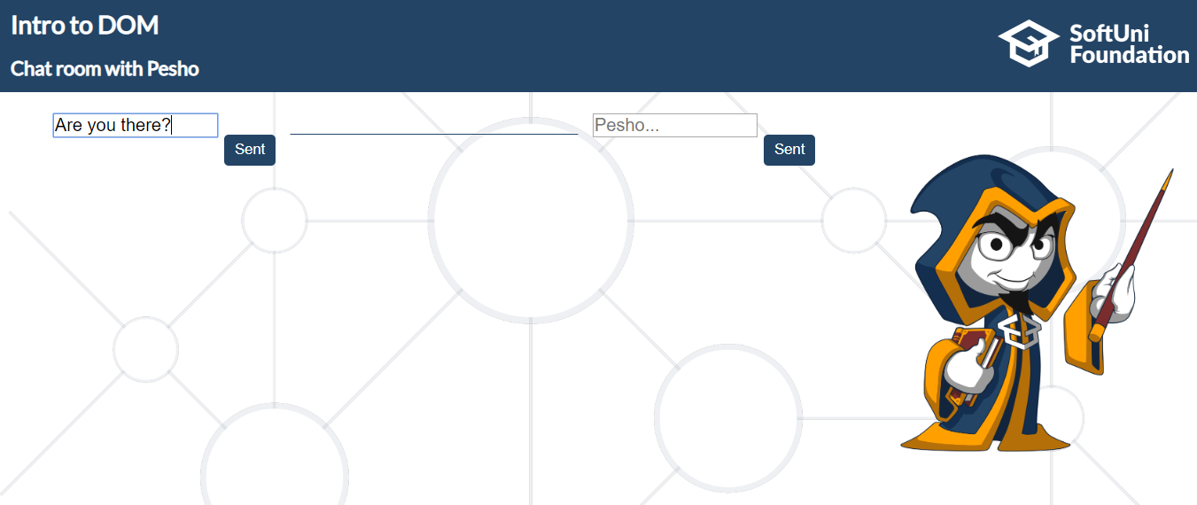

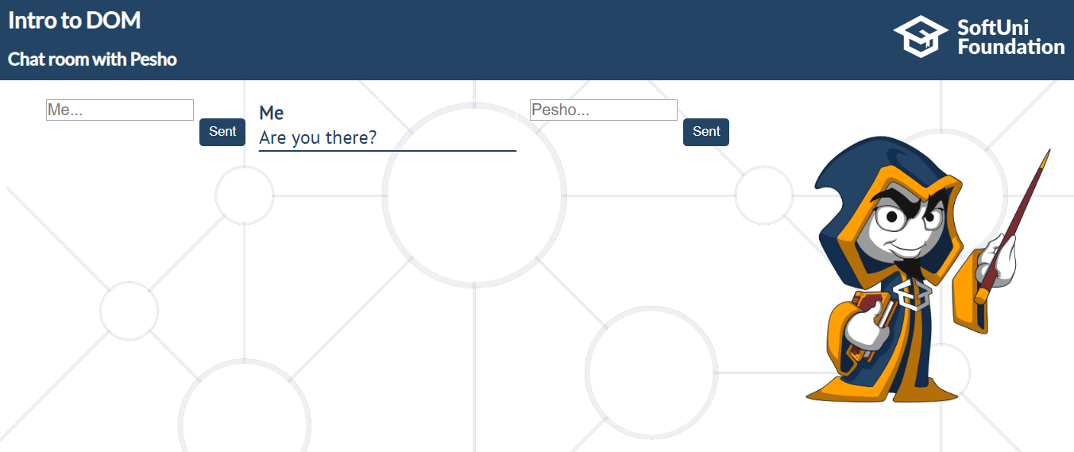

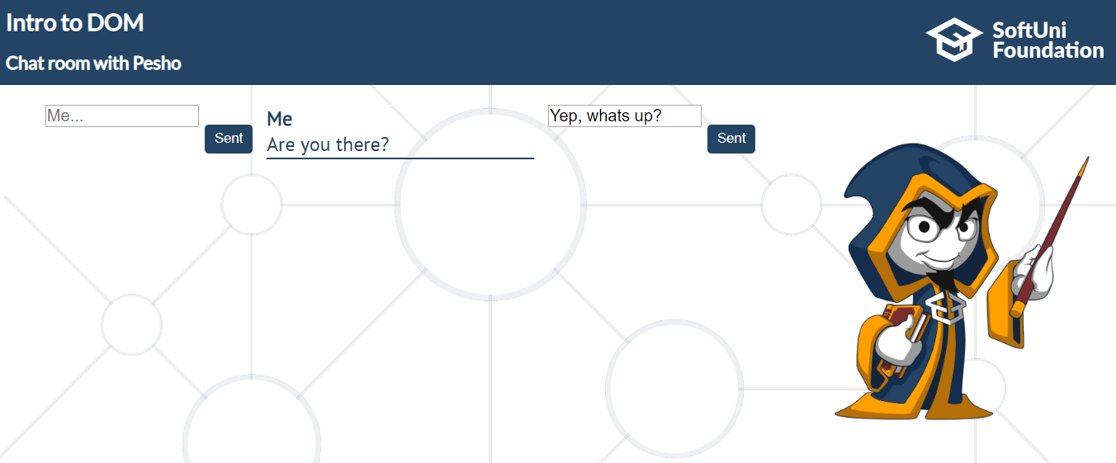

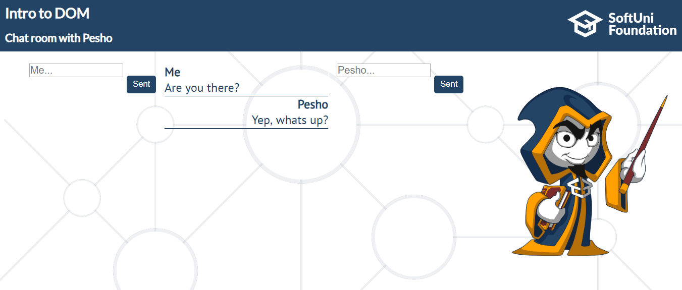

## Encode and Decode Messages

In this problem, you should **create a JS functonality** which **encodes and decodes some**

**messages which travel to the network.**

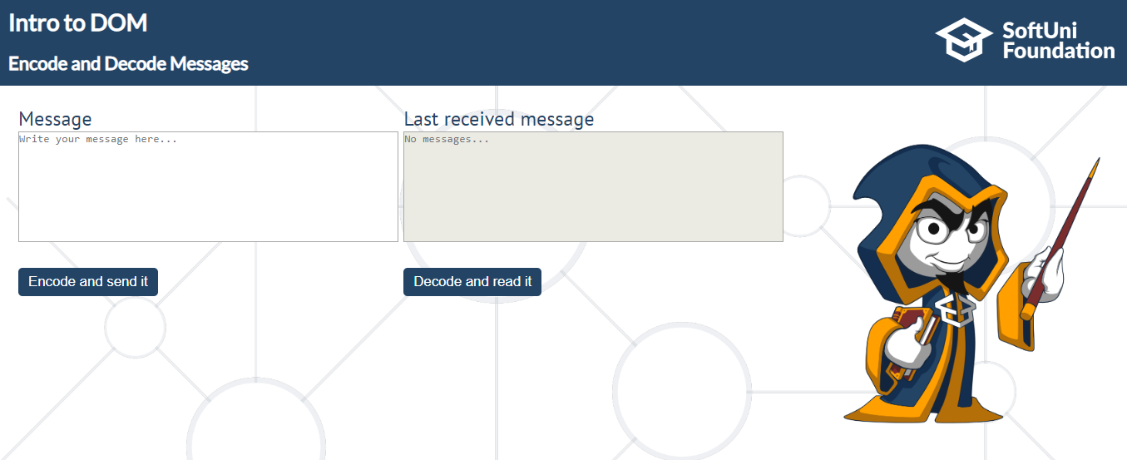

This program should contain **two functionalities**.

The first one is to **encode the given message** and **send it** to the **receiver**.

The second one is to **decode the received message** and **read it (display it)**.

When the "**Encode and send it**" button is clicked, you should get the given message from the first textarea. When you get the current message, you should encode it as follows:

You **should change** the **ASCII CODE** on **every single character** in that message, when you **add 1** to the current **ASCII NUMBER**, that represent the current character in that message.

When you do that just **clear** the **sender textarea,** and **append the encoded message** to the **receiver textarea.**

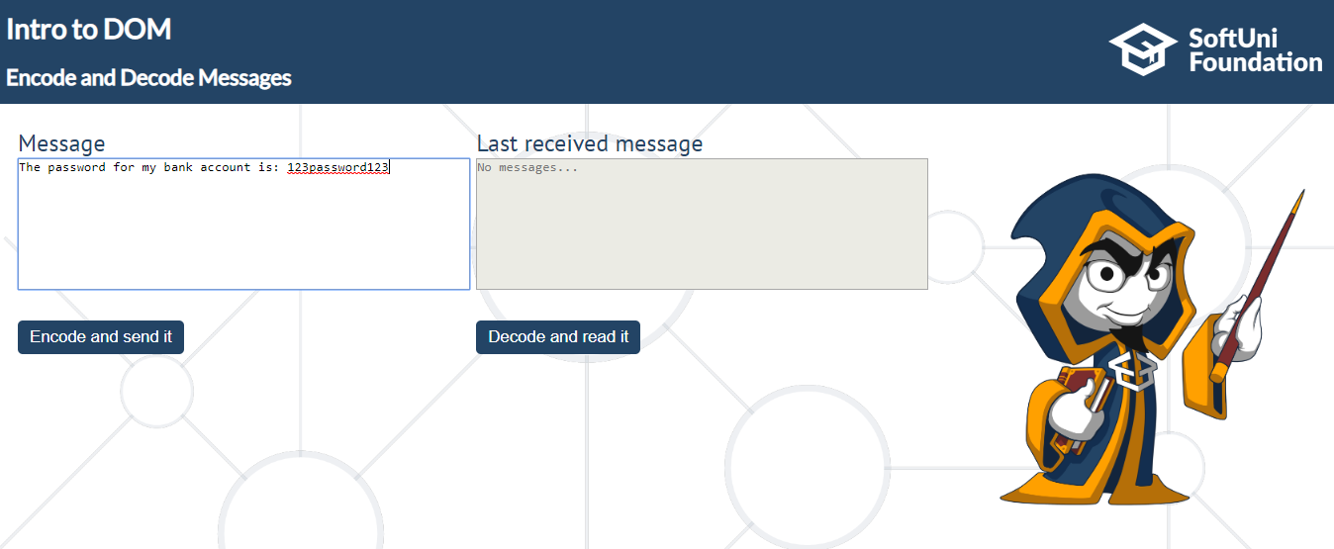

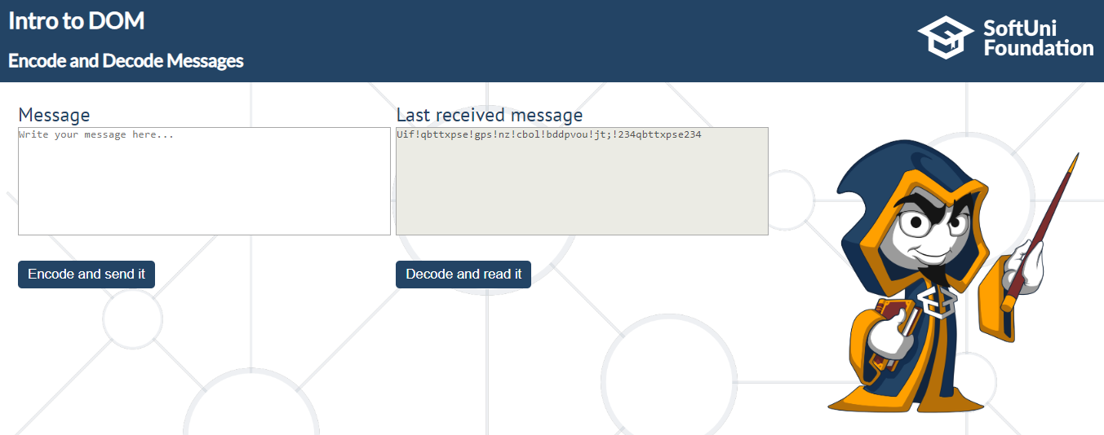

After that, when the "**Decode and read it**" button is clicked. You need to get the **encoded message** from **the receiver textarea** and do the **opposite logic** from encoding, **subtract 1** from the current **ASCII NUMBER**, that represents the current character in that message.

When you do that, just replace the **encoded message** with the already **decoded message** in the receiver textarea, to make it readable.

// decoding single message and clearing the textarea

document.body.innerHTML = `<div id="container">

<nav id="navigation">

<div id="navigation-text">

<p id="lecture-name">Intro to DOM</p>

<p id="problem-name">Encode and Decode Messages</p>

</div>

<img id="logo-img" src="SoftUniFoundation_Logo_OneLine_White@2x.png" alt="logo">

</nav>

<main id="main">

<div id="exercise">

<div>

<p>Message</p>

<textarea placeholder="Write your message here..."></textarea><br>

<button>Encode and send it</button>

</div>

<div>

<p>Last received message</p>

<textarea disabled placeholder="No messages..."></textarea><br>

<button>Decode and read it</button>

</div>

</div>

<img id="softUni-person-img" src="cw_2_New_Logo.png" alt="softUni-person">

</main>

<footer id="footer">

<p id="footer-text">Check your solution here: <span id="check-judge">https://judge.softuni.bg/Contests/356</span>

</p>

</footer>

</div>`;

result();

$("textarea")[0].value = "pesho";

$("button").first().trigger("click");

let textAreaValue = $("textarea")[0].value;

let resultValue = $("textarea")[1].value;

expect(textAreaValue).to.equal("");

expect(resultValue).to.equal("qftip");

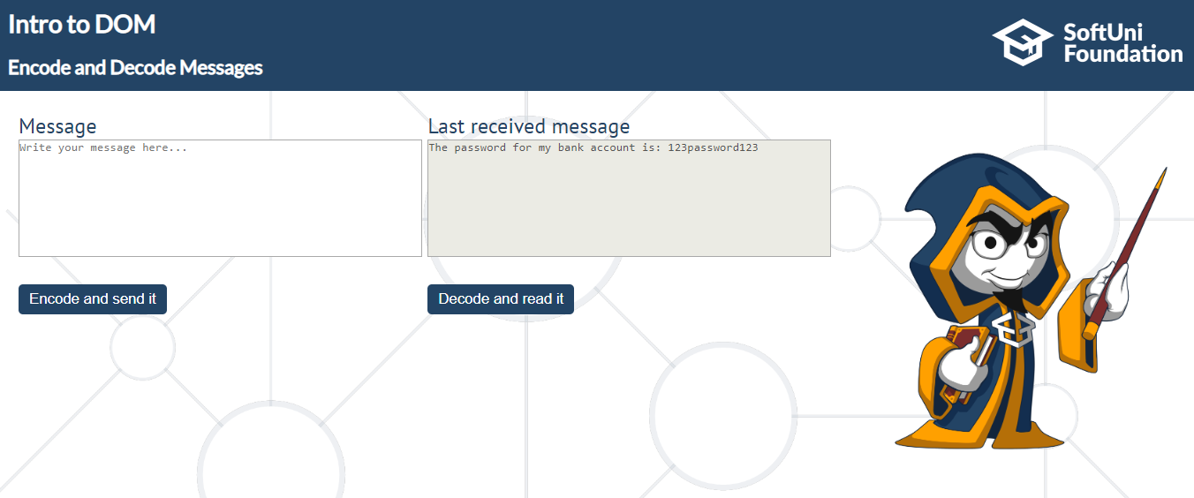

## Locked Profile

In this problem, you should **create a JS functonality** which **shows** and **hides** the additional

information about users.

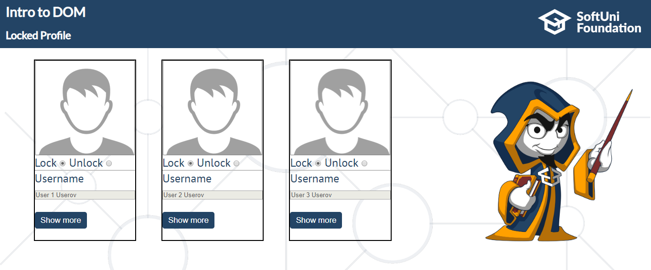

When one of the "**Show more**" **buttons** is clicked, the **hiden information** inside the div should

be shown, only if **the profile is not locked**! If the current profile is **locked,** nothing should

happen.

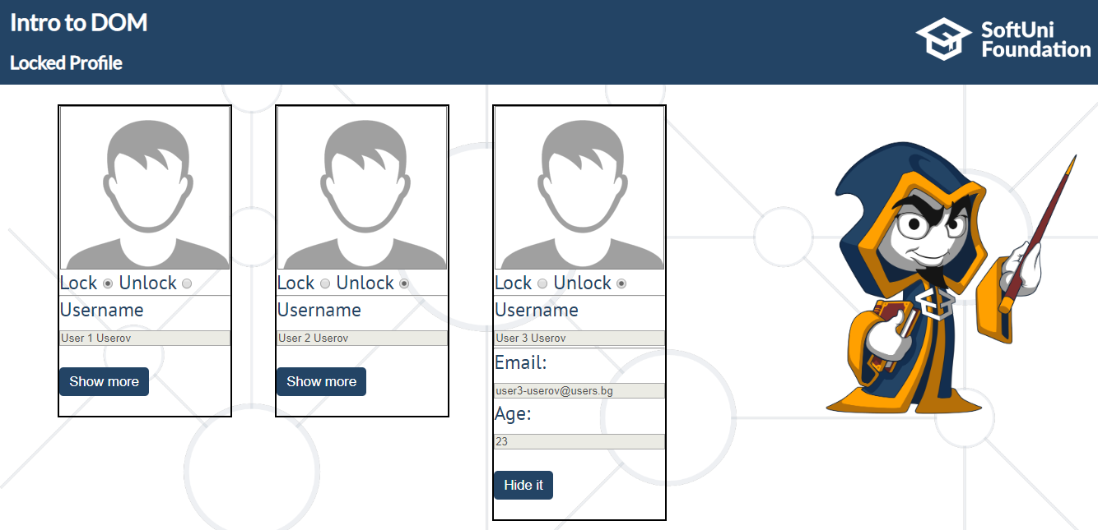

If the **hidden information is displayed** and we **lock** **the profile again**, the "**Hide it**" button

should **not be working**! Otherwise, when the profile is **unlocked** and we click on the "**Hide it"**

button, the new fields must hide again.

## Number convertor

In this problem, you should **create a JS functonality** that **converts** a **decimal** **number** to **binary**

and **hexadecimal**.

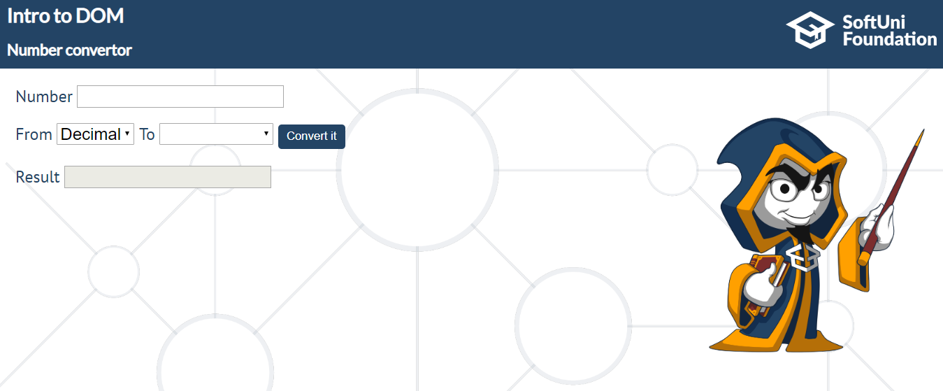

The given number will always be in **decimal format.** The "**from"** select menu will only have a

**Decimal** option, but the "**To"** select menu will have **two options**: **Binary** and **Hexadeicmal**.

This means that our program should have the functionality to **convert** **decimal** to **binary** and

**decimal** to **hexadecimal**.

When the "**Convert it** "button is **clicked**, the expected result should appear in the "**Result"** input

field.

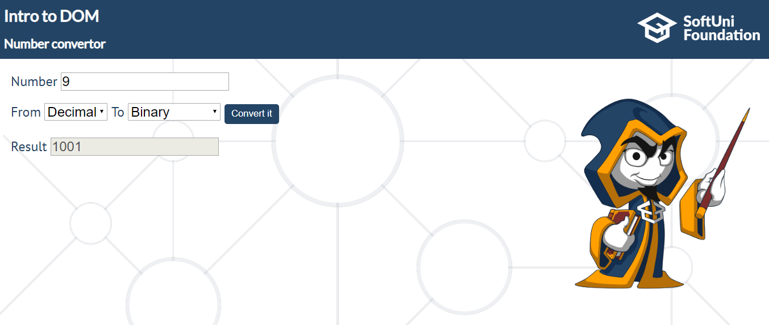

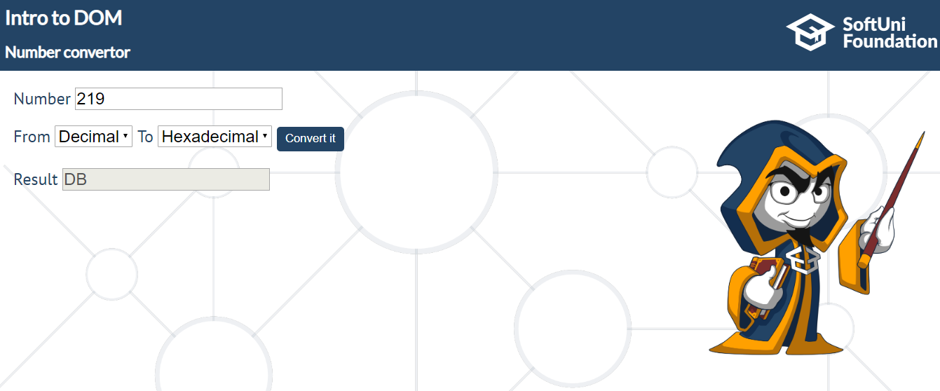

## Softuni Quiz

In this problem you should **create a JS functonality** about a quiz.

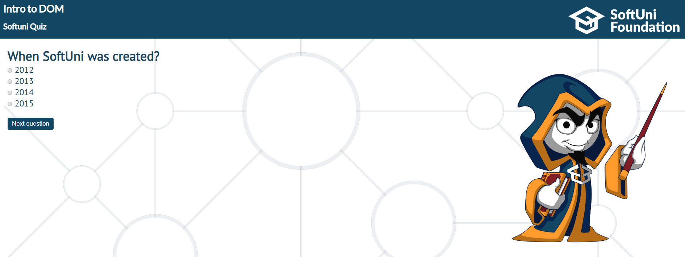

There are three **sections**, that contain **one question** **and 4 possible answers. The right answer**

**is only one!** The expected functionality is when one of the **radio buttons is selected**, and "**Next**

**question**" button is clicked, the next section **must appear (if any…)** If the third (last one) section

is visible, when you press the button, "**Get the results", the final score** must show into the

result div.

If all questions are answered right, you need to print: "`**You are recognized as top SoftUni fan!**",

otherwise just print "**You have {rightAnswers} right answers**".

The right answers are (**2013, Pesho and Nakov**).

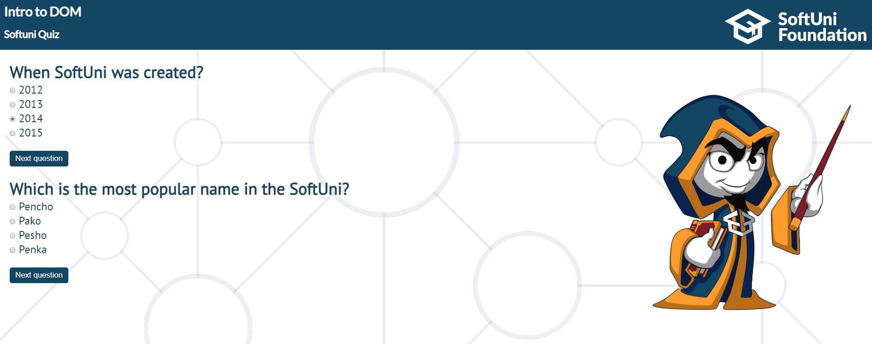

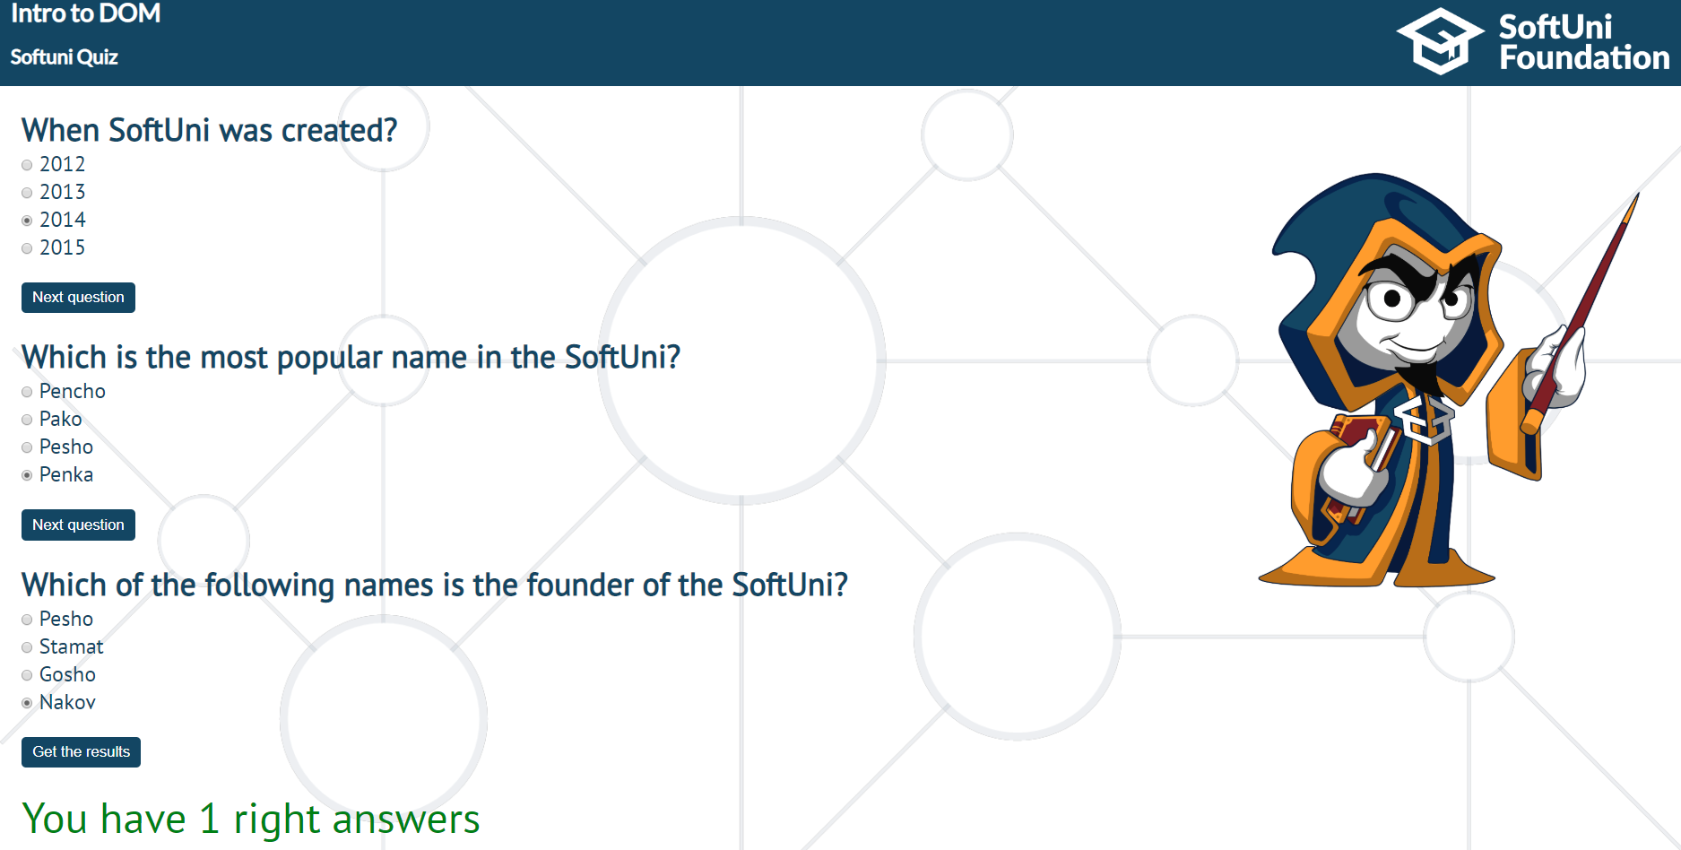

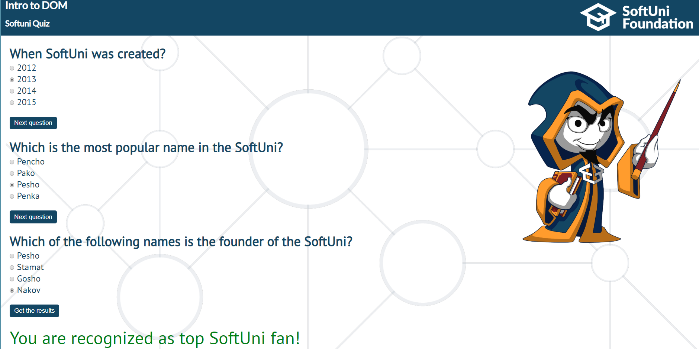

## Table – Search Engine

In this problem, you should **create a JS functonality** that **searches** in a **table** by given input.

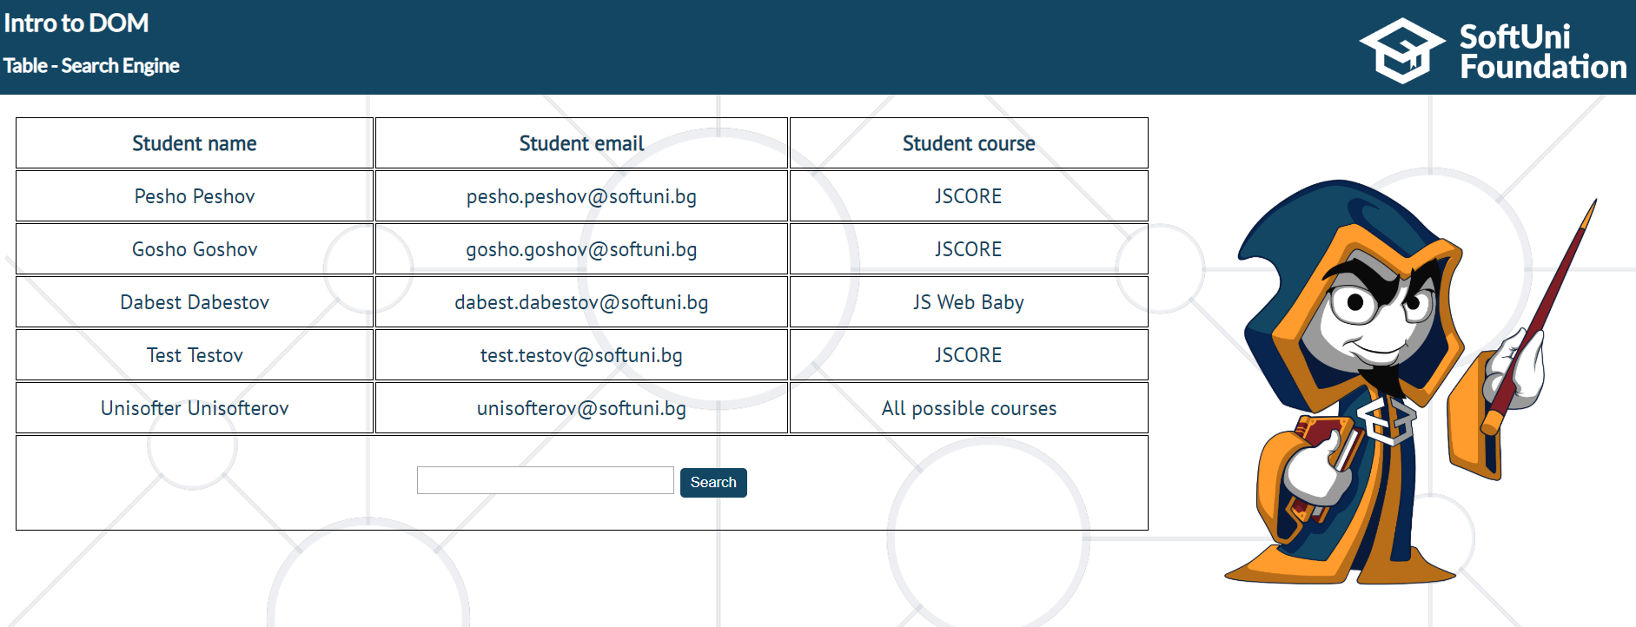

When the "**Search**" **button** is **clicked**, you should go through all cells in that table except for the first row (Student name, Student email and Student course) and you also need to check if the given input matches somewhere. (whether it's a **full word** or a **single letter**).

If any of the rows contain the string we have submitted, you need to add a **select class**  to that row. If more than one row contains that string, add the **select class** to all of them.

Оtherwise, if we **cannot** find anything, **nothing should happen**.

**Note:** After every search ("Search" button is clicked), you should **clear** **the input field** and **remove** **all already selected classes** (if available) from the old search, in order for the **new search** to come out only the **new result**.

For instance, if we try to find **dabest:**

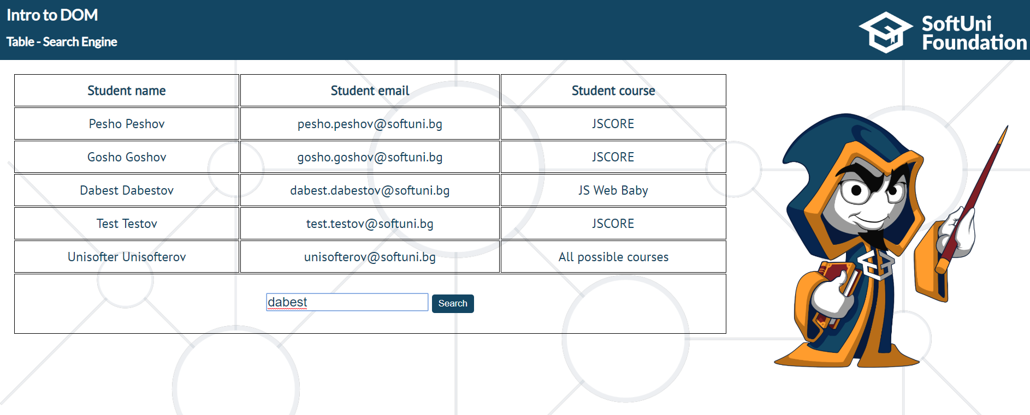

The result should be:

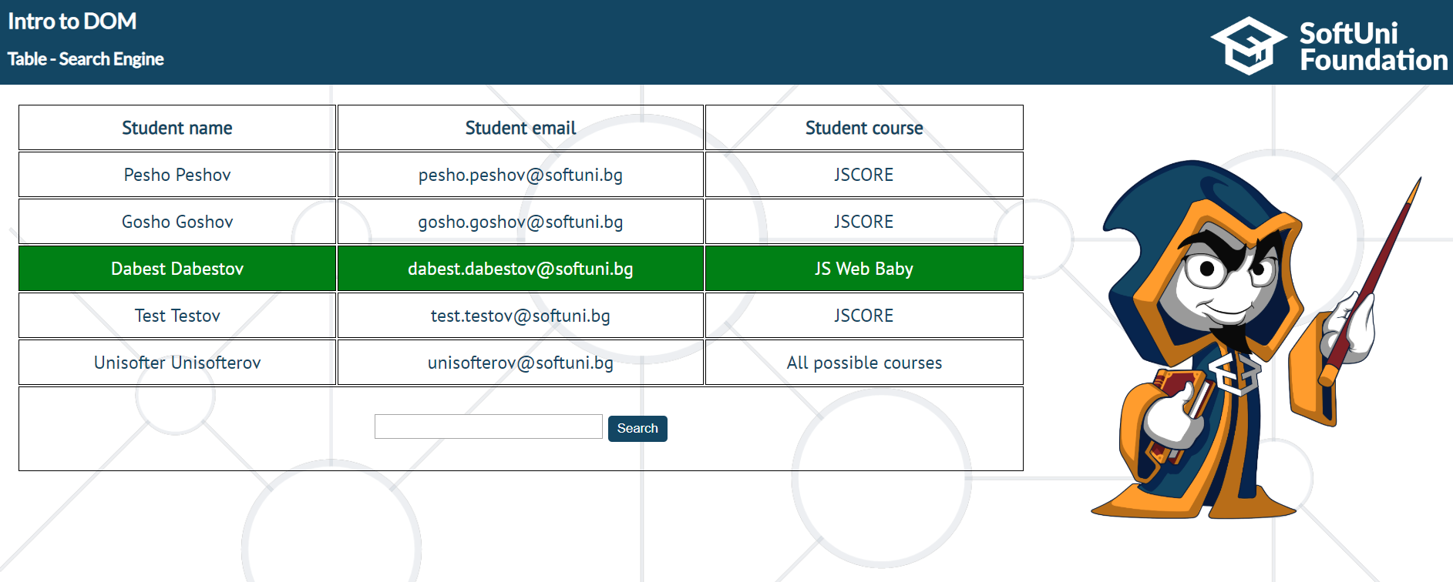

And if we try to find all students who have enrolled for the **jscore** course:

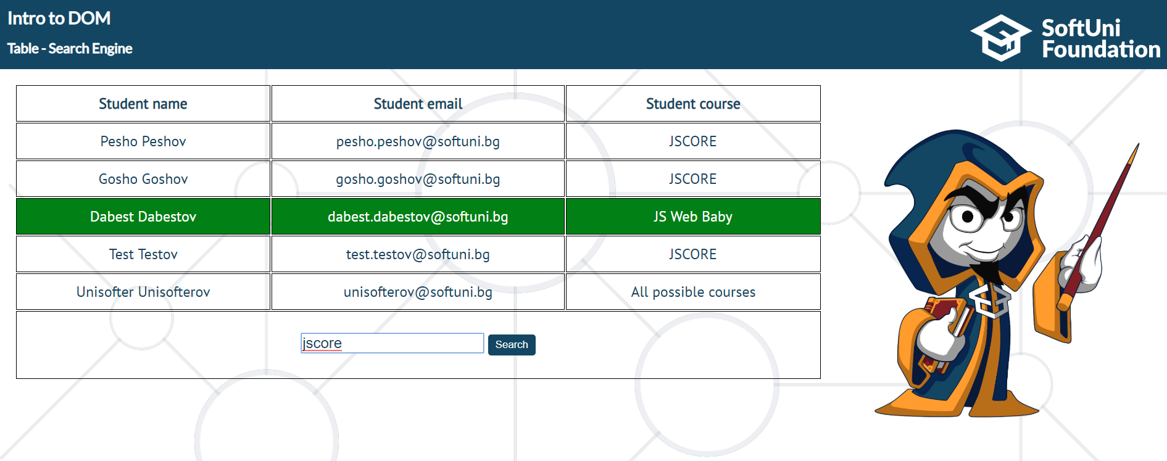

The expected result, should be:

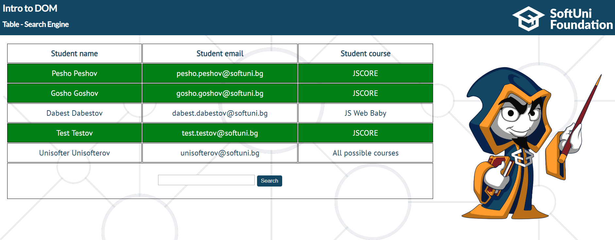

## Toto numbers

In this problem, you should **create a JS functonality** which **visualizes toto numbers.**

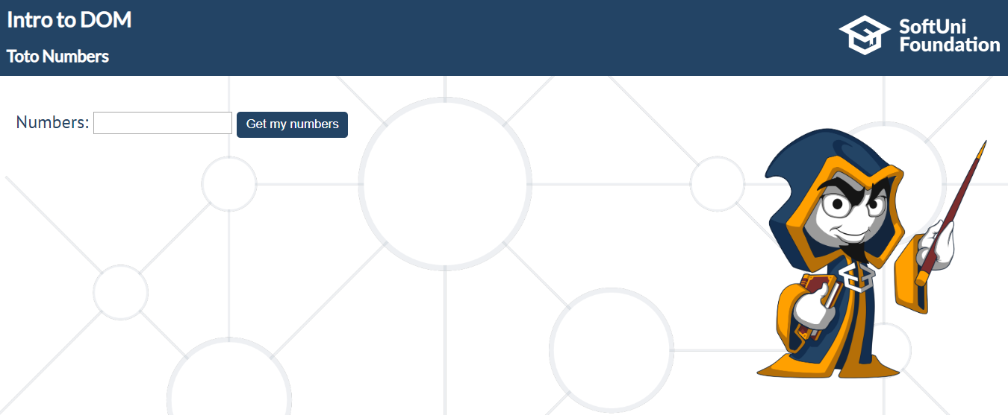

**The Numbers input field should receive exactly 6 numbers in the range of [1 – 49].**

**If** numbers input contains **more or less** numbers **than 6** or **one of all** the given numbers **does not cover** **the necessary range**, **nothing should happen**.

The expected functionality is as follows:

**If the above conditions are met**, when the "**Get my numbers"** **button** is **clicked,** you need to **create 49 div elements** and **append** them to the **div** which has an **id** "**allNumbers**".

**Еach** of these 49 div elements **must** have the current number (1-49) as text inside them and **class** "**numbers"**.

If the **current number** is one of the Numbers from the **numbers field,** the **current div** should have an **orange background**.

When all numbers (div elements) **are visualized**, you should **disable** **the numbers input field** and **the "Get my numbers" button**.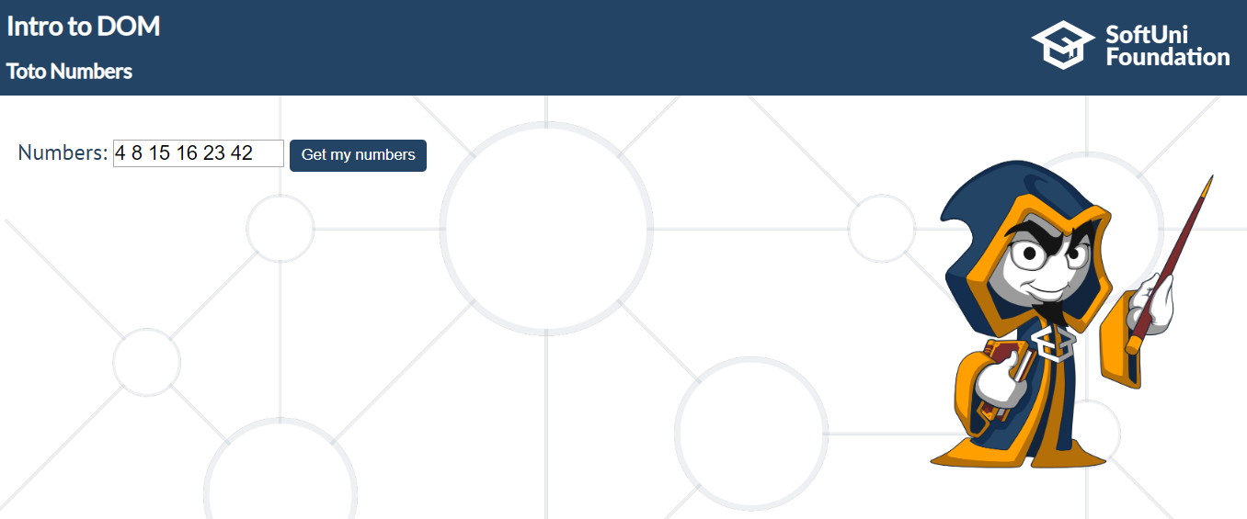

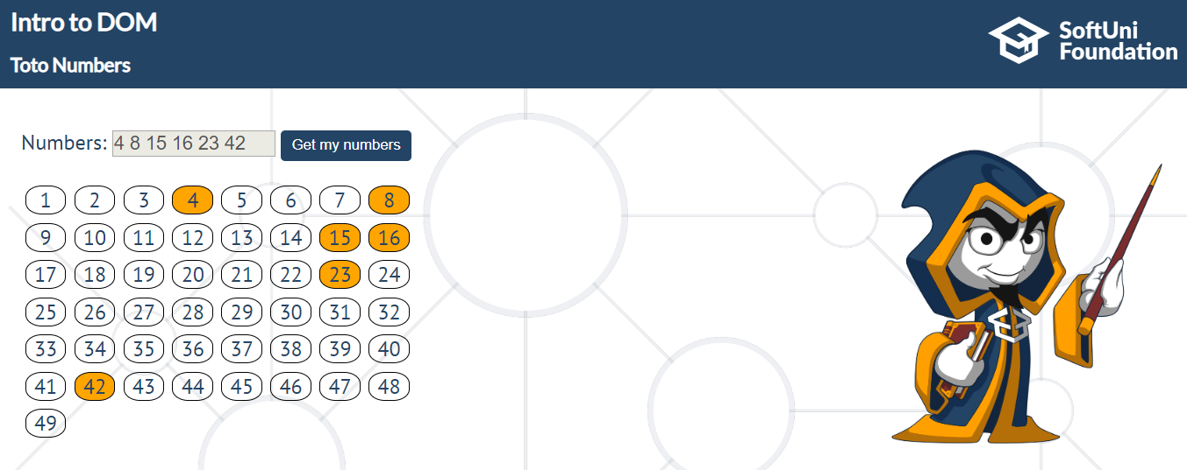

## Virus Installer

In this problem, you should **create a JS functonality** that represents a "Wizard" which installs a

"virus" on your computer.

To have the virus installed successfully, you need to go through **three steps.**   
At the beginning (when you open the html file) you will see:

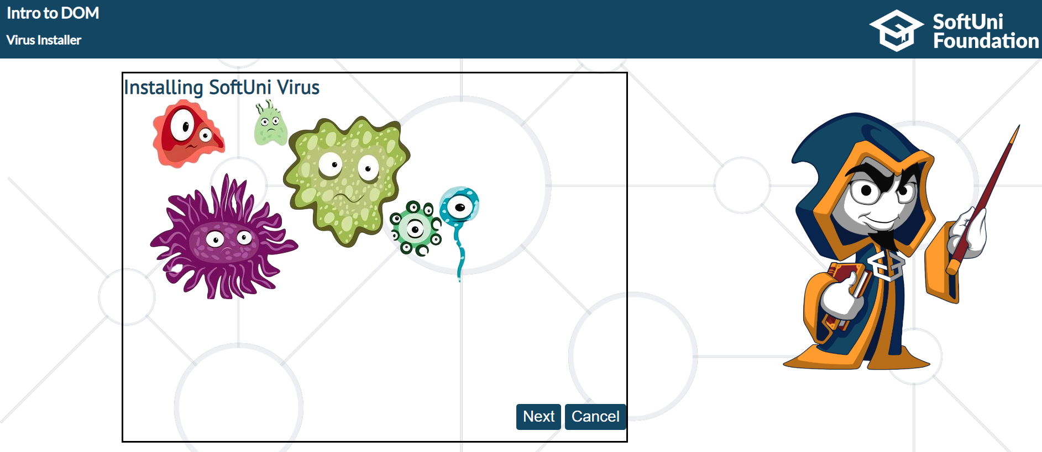

If the "**Next** **button**" is clicked, you should switch to the next step. (First Step)

You need to hide the background image into the **id content** element, and show the **firstStep div.**

Expected result is:

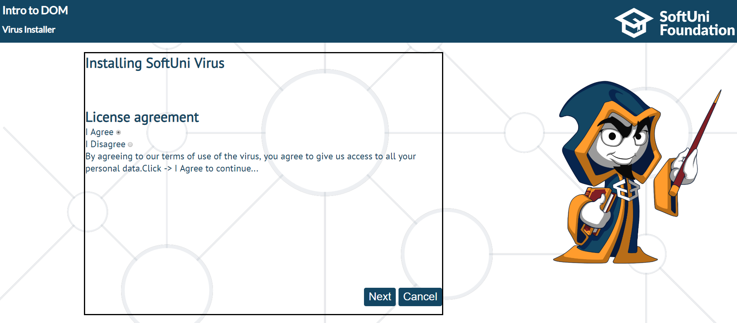

If we **try** to **click** on the "**Next** **button**", when "**I Disagree**" radio button is selected, **nothing**

**should happen!** Because we **do not aggree** with the license agreement. Otherwise, when we

"Agree" and we click on the "Next" button. **First step** should **hide** and next one should show

(**secondStep**). On the second step, you need to use the **setTimeOut function** to continue. As you

can see, the text inside it is "**Wait a 3 seconds….**" **Three seconds** after the **second step appears**,

**the button should appear near the "Cancel button".**

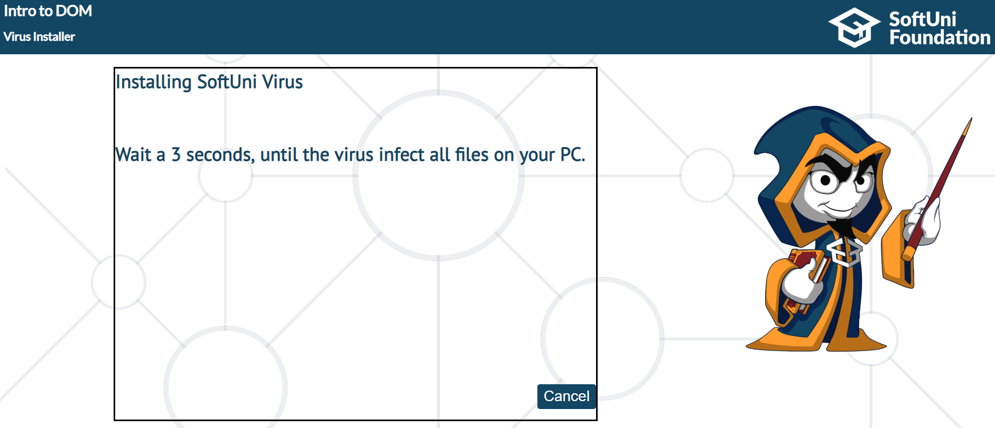

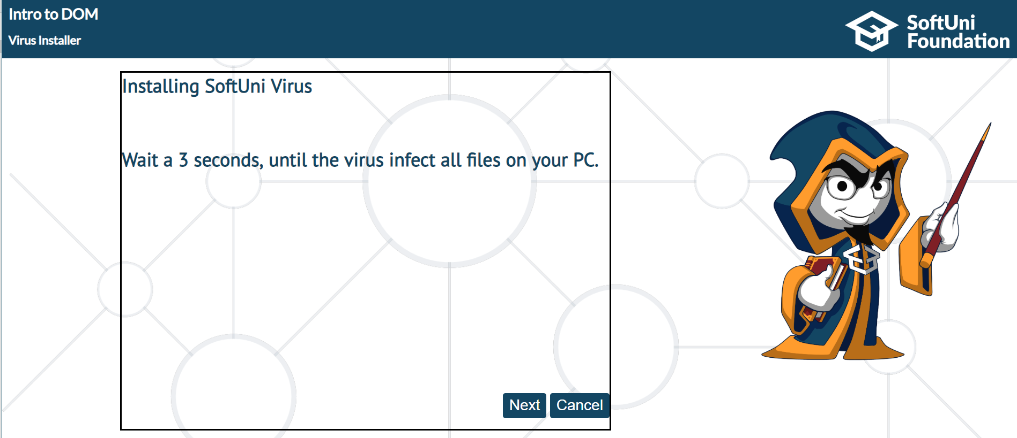

When we see the "**Next button**" and we click it, the last (thirdStep) stage in this "**installer**"

needs to be visualized.

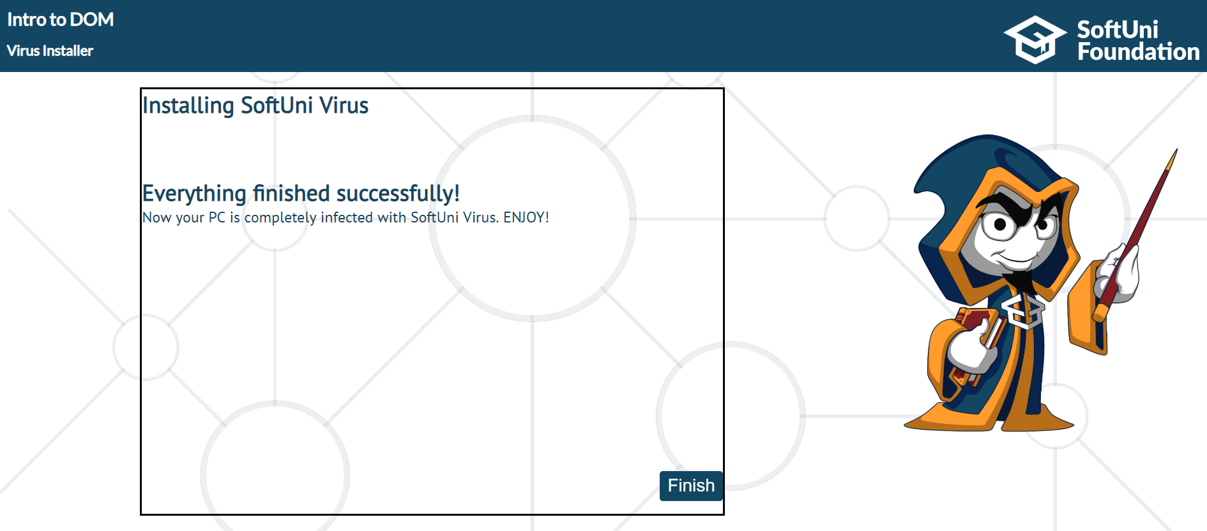

This is the **closing** stage of the "program"…

When we click on "**Finish**" or on **each** of the "**Cancel**" buttons, regardless of the step (firstStep,

secondStep..), we should hide the whole **section** that contains (**content**, **h1**, **buttons**…) or simply

hide **everything** apart. The expected result is:

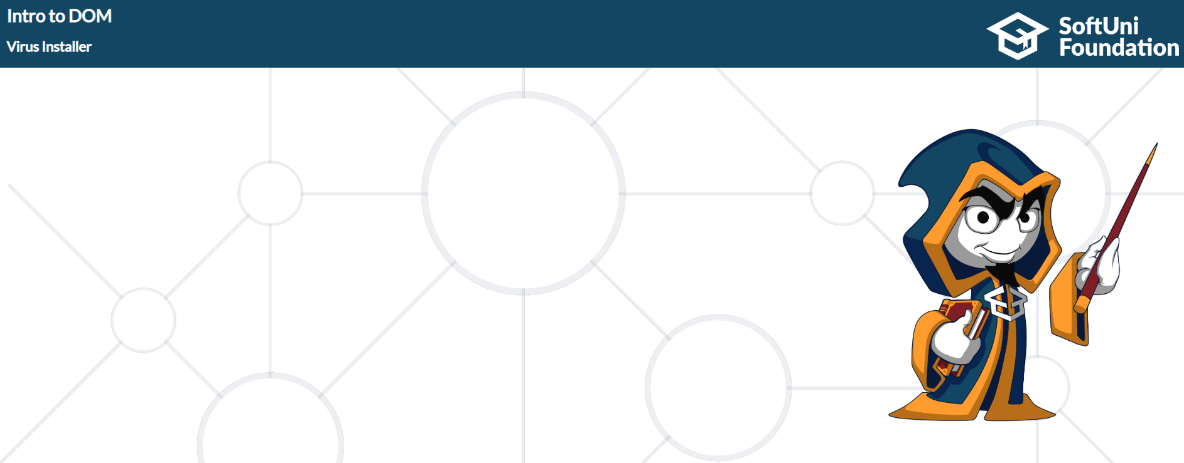

## No Signal

In this problem, you should **create a JS functonality** which puts a **div** on a **random** **position**.

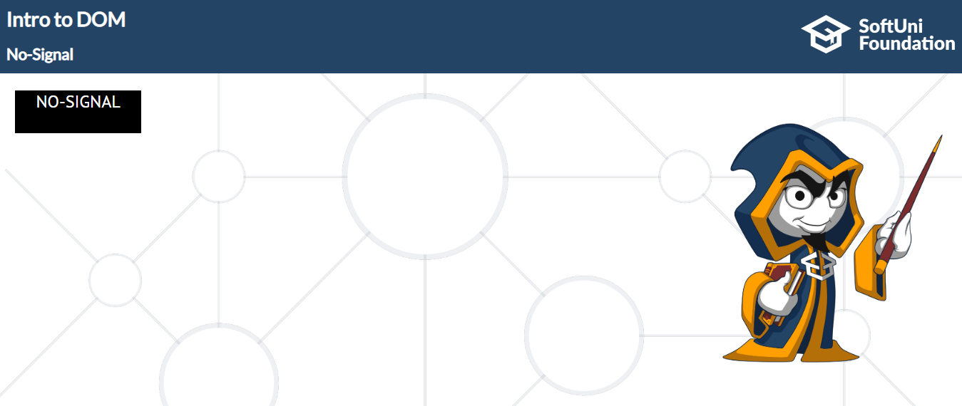

You should work with the **position styles** on that div element. (**margin**)

The **horizontal range** must be **1-81** in **percent** (%).   
The **vertical range** must be **1-45 vh** (viewport height).

Use **setTimeOut** and **Math.Round** to generate **random** **position** and **change** **it** every **2000 ms.**

